**DAILY ONLINE ACTIVITIES SUMMARY**

|  |  |  |  |  |  |  |  |
| --- | --- | --- | --- | --- | --- | --- | --- |
| **Date:** | **5/06/2020** | | | | **Name:** | **Imran Khan** | |
| **Sem & Sec** | **8th A** | | | | **USN:** | **4AL16CS040** | |
| **Online Test Summary** | | | | | | | |
| **Subject** | | **BDA** | | | | | |
| **Max. Marks** | | **30** | | **Score** | | **16** | |
| **Certification Course Summary** | | | | | | | |
| **Course** | **Modern java programming** | | | | | | |
| **Certificate Provider** | | | **udemy** | **Duration** | | | **3 HOURS** |
| **Coding Challenges** | | | | | | | |
| Problem Statement:  Write a C Program on strings.. | | | | | | | |
| **Status: Solved** | | | | | | | |
| **Uploaded the report in Github** | | | | **yes** | | | |
| **If yes Repository name** | | | | **Imran040** | | | |
| **Uploaded the report in slack** | | | | **yes** | | | |

Online test details:

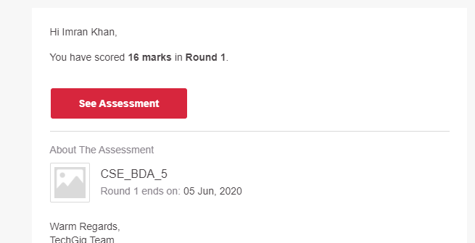

**Certification Course Details**:

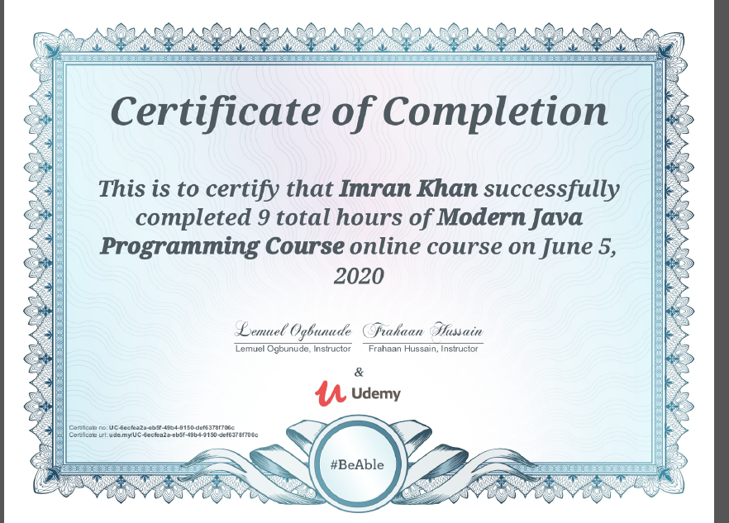

**Coding Challenges Details**:

**program1:**

|  |  |  |  |
| --- | --- | --- | --- |
|  | | | |
|  | |
| #include <stdio.h> | |
|  | | #include <string.h> |
|  | |  |
|  | | int main() |
|  | | { |
|  | | char str[100]; |
|  | | int i; |
|  | | int freq[256] = {0}; |
|  | | printf("Enter a string\n"); |
|  | | gets(str); |
|  | | for(i = 0; str[i] != '\0'; i++) |
|  | | { |
|  | | freq[str[i]]++; |
|  | | } |
|  | | for(i = 0; i < 256; i++) |
|  | | { |
|  | | if(freq[i] != 0) |
|  | | { |
|  | | printf("%c %d\n", i, freq[i]); |
|  | | } |
|  | | } |
|  | | return 0; |
|  | | } |